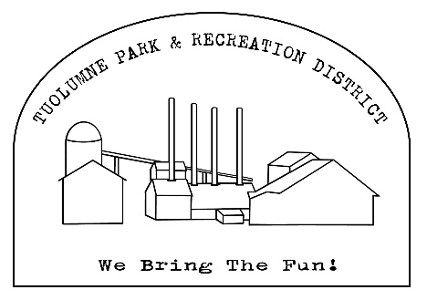
Tuolumne Park and Recreation District
18603 Pine Street Tuolumne, CA 95379
209.928.1214 admin@tuolumnerecreation.com

Tuolumne Community Center Rental Fee Schedule
******TENTAVTIVE AND SUBJECT TO CHANGE******

Community Center Rental Fee 4 hours $100.00
All Day* $200.00
Required with all Rentals:
Non-Refundable Cleaning Fee $50.00
Refundable Deposit $300.00

Extras:
Garbage Disposal Fee for trash left behind $25.00
Wi-Fi Password Fee $15.00
Tables $5.00 each
Chairs $0.50 each
Early Set Up Fee* $50-75.00
Projector and Screen use $25.00

Sound System Usage: Not applicable at this time

Special Event Insurance Requirement: All events MUST be accompanied by a Special Event Certificate naming Tuolumne Park and Recreation District as the additional insured.

All facilities must be clean prior to departure.
All trash must be removed to avoid the garbage disposal fee.
Please put all unused ice in the sink to melt.
Deposit is refundable if all rental conditions are met.

*All day use is 9am-10pm. Event must be 100% cleaned up and all guests out by 10pm to avoid an extra charge.
*Early set up is 7am the morning of the event for $50 or 5pm-10pm the event before (IF available) for $75.00.
Alcohol Usage/Sale: All events that sell alcoholic beverages require a permit. The Daily License Application for ABC is available at www.abc.ca.gov. The permit process can take a few weeks to complete so please begin the process in plenty of time prior to the event.

**Special Rates are available for Service Groups/Organizations on repetitive use needs.

