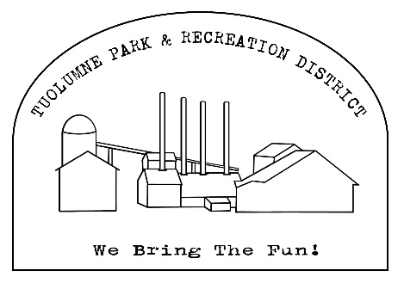
Tuolumne Park and Recreation District
18603 Pine Street
Tuolumne, California 95379 (209)928-1214
admin@tuolumnerecreation.com
www.tuolumnerecreation.com

Christmas Market Agreement 2025
- Sale times shall be Friday 12/12/25 from 4:00pm to 8:00pm and Saturday 12/13/25 from 10:00 am to 2:00 pm. Please plane to stay for the entire event.
- Set up time is Friday at 2:30pm.
- No illegal items may be sold. Alcohol Prohibited.
- The Tuolumne park and recreation district will in no way be responsible for lost, stolen, misplaced or damaged merchandise or injury of vendors before during or after the sale.
- Fee: $60 for both days. Must be received prior to set up. Space is 10x10. If Vendor needs more than that there will be an additional charge.
- Food vendors are required to submit a copy of their health department permit with this agreement. No food sales will be allowed without a permit.
- Removal of all trash and other items are responsibility of the vendor.
DO NOT USE TUOLUMNE PARK AND RECREATION FACILITIES FOR DUMPING

Name:_______________________________________________________________
Mailing address:_______________________________________________________________
Phone number:________________________________________________________________
Email Address:_________________________________________________________________
Please list the type(s) of items you will be selling:_____________________________________
Will you need access to an electrical outlet? (please circle one) Yes or no
Applicant/ User agrees to be solely responsible to any and all liability, claims, loss, demands, damages, costs and expenses, including attorney’s fees, arising out of or resulting from injury to persons or damage to property which arise out of its use of District’s facilities. Applicant / User agrees to use the described facilities specified above according to conditions set forth herein. Applicant/ User agrees to defend, indemnify and hold harmless district, its officers, agents, employees and volunteers against any and all such claims, demands, causes of action, suits and expenses arising out of the use of these facilities.
I HAVE CAREFULLY READ THIS AGREEMENT AND REALEASE AND FULLY UNDERSTAND ITS CONTENTS, I AM AWARE THAT THIS IS A REALEASE OF LIABILITY AND A CONTRACT BETWEEN THE ABOVE DISTRCIT AND MYSELF AND I SIGN IT OG MY FREE WILL.
Signature:__________________________________ Name Printed:_________________________________ Date:____________
Cash Check: Amount Paid $__________ Check # _____________ Date paid:_________________
All contracts need approval. Receipt of contract and payment is not acknowledgement of approval and is not valid until signed and dated by an authorized TPRD Employee.
Approval by:________________________ Signature:____________________Date:_________________

