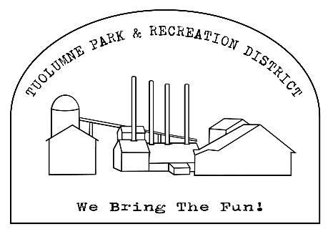

Tuolumne Park and Recreation District

18603 Pine Street *Tuolumne, California 95379*

*(209) 928-1214 • FAX (209) 928-1205*

admin@tuolumnerecreation.com

[www.tuolumnerecreation.com](http://www.tuolumnerecreation.com)

AGENDA

REGULAR MEETING OF THE TPRD BOARD OF DIRECTORS

Wednesday September 10th 2025– 6:00 PM

Meeting will be held at 18603 Pine Street, Tuolumne, CA 95379

1. PLEDGE OF ALLEGIANCE

1. APPROVAL OF AGENDA (additions or deletions)
2. Opportunity for members of the public to address the Board on any item under the subject matter of the jurisdiction of the District that is not on the agenda. Limit comments to no more than 5 minutes.
3. CONSENT AGENDA: (Acted on as one item unless withdrawn by request of the Board member or a member of the public)

Items on the Consent Agenda are considered to be routine and enacted by one or more motions. Any item maybe removed for discussion and made a part of the regular agenda at the request of a member of the Board. An announcement shall be made before action is taken on any item, that the public may address an item on said Consent Agenda.

* 1. Approval of Regular Meeting Minutes – August 2025
  2. Approval of Routine Bills
  3. Approval of August Warrant

1. CORRESPONDENCE

6. SAFETY MEETING

7. REPORTS:

7.1 District Manager

7.2 Maintenance Report

7.3 Office/Events

7.4 Financial

7.5 Projects

8. DISCUSSION/ACTION ITEMS

8.1 Consideration and Update of County Contract

9. ITEMS TO DISCUSS FOR NEXT MEETING

10. ADJOURNMENT

|  |
| --- |
| In accordance with the Americans with Disabilities Act, if you need special assistance (i.e. auxiliary aids or services) in order to participate in this public meeting, please contact Office Staff of Tuolumne Park and Recreation District (209-928-1214). Notification 48 hours prior to the start of the meeting will enable Office Staff to make reasonable accommodations to ensure accessibility to this public meeting. |

At the discretion of the Board, all items appearing on the agenda whether or not expressly listed for action, may be deliberated and may be subject to action by the Board. Late agenda material can be inspected in the TPRD office at 18603 Pine Street, Tuolumne, CA

Note: Please notify the District Office Staff at (209) 928-1214 at least 7 days in advance of the meeting with additional items. The Board meets on the second Wednesday (except in June, July, and August where they meet on Tuesdays) of each month at 6:00pm at the TPRD office. Regularly scheduled meetings for 2025: 1/8, 2/12, 3/12, 4/9, 5/14, 6/10, 7/9, 8/13, 9/10, 10/12, 11/12, 12/10.

Board of Directors:

MARTY ANDERSON ٠ 18505 Baker Street, Tuolumne, CA 95379 ٠ 209-928-1646

LAURA BURNS٠PO Box 1082, Tuolumne, CA 95379٠209-770-5683٠Lburns@frontiernet.net

MARK FERREIRA ٠ PO Box 4507, Sonora, CA 95370٠209-814-7941٠ email: c740ferreira@gmail.com

AARON RASMUSSEN▪ PO BOX 263, Tuolumne, CA 95379 ▪ 209-206-6768 ▪ email aramussentprd@yahoo.com

GRETCHEN SULLIVAN ٠ PO Box 1495, Tuolumne, CA 95379 ٠ 209-352-0380 email: gretchensully7@gmail.com Certification of Posting I certify that on September 5th , 2025, I posted a copy of the foregoing agenda near the regular meeting place of the Board of Directors of Tuolumne Park and Recreation District, said time being at least 72 hours in advance of the meeting of the Board of Directors (Government Code Section 54954.2)

Executed at Tuolumne California on September 5th , 2025

_____________________________________________