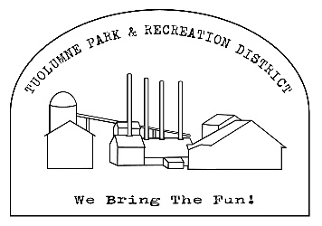
Tuolumne Park and Recreation District
Christmas Parade Entry Registration Form

Staging begins at 5:00 pm on Fir Ave between Carter street and Pine street
Entry Name:_____________________________________________________________________
Contact:___________________________________________________________________
Address:___________________________________________________________________
Phone:_________________________Email:______________________________________
Category

- Auto ( Individual/group)
- Horse (Individual/group)
- Bicycle (Individual/group)
- Float
- Band
- Animal
- Organization
- Veteran
- Other________

Briefly Describe your entry:
_________________________________________________________________________________________________________________________________________________________________________________________________________________________________
How would you like your entry announced?
_________________________________________________________________________________________________________________________________________________________________________________________________________________________________
Important Notice
For safety’s sake Alcohol is NOT permitted
Santa entries are NOT permitted
Nothing may be thrown to the crowd
WATCH YOUR SPEED!
Tuolumne Park and Recreation District reserves the right to reject any entry at it sole and absolute discretion. The parade is subject to cancellation due to moderate to heavy rain
In consideration of acceptance or this entry, I, The undersigned , on behalf of myself, the owners and participants involved in our entry, hereby waive any and all claims against the Tuolumne Park and Recreation District arising out of our participation in the parade or while in Tuolumne.

Signature of Contact Person : ________________________________ Date:____________
Return entry forms to:
Tuolumne park and Recreation District – 18603 pine street Tuolumne Ca 95379
Call for More information: 209-928-1214 Admin@tuolumnerecreation.com

